**Introduction**  
**Traversal of a Graph** => **visiting each vertex exactly 1x**  
* In a LinkedList we start traversing from the 1st node of the list, in a tree we start from the root. In graph we don’t have any particular first vertex or root vertex.  
=> **We can start the traversal from any vertex**.  
=> **Different sequences for different start vertices**.  
* In a LinkedList or a Tree, all the nodes are visited in any traversal algorithm.  
* **In a Graph, only the vertices which are reachable from the start vertex will be visited**.  
* **If we want to visit all the vertices, then we have to select another start vertex from the remaining unvisited vertices**.  
* While traversing a LinkedList or a Tree, we never reach a node more than once.  
* **In a Graph, we can reach a vertex more than once because there can be more than 1 path to reach a vertex**.  
=> **So while Traversin a Graph, we have to make sure that each vertex is visited only 1x**.  
* In traversal of a LinkedList or a Tree, we get unique traversal sequences.  
* **In a Graph, we can have different traversal sequences for the same traversal technique - for example because of different starting vertex or even for the same vertex there is no natural order among the successors of a vertex, so they can be visited in different orders**.  
=> **The order depends on the implementation**.  
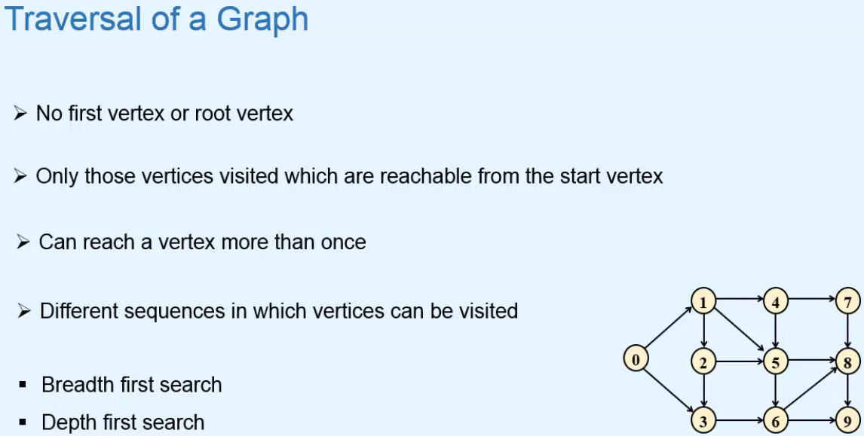

**Breadth First Search**  
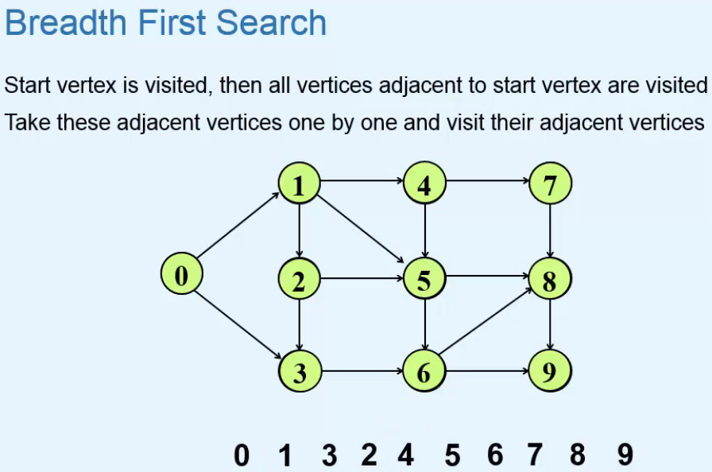  
=> **We can see that this BFS traversal is in a way equivalent to Level Order Traversal of Trees**.  
=> **We can have different sequences**.  
* Let’s take 2 as the start vertex this time:  
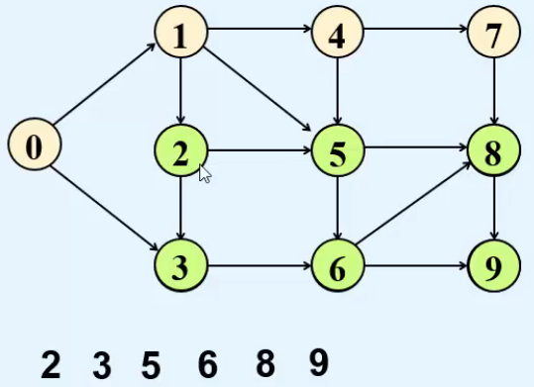 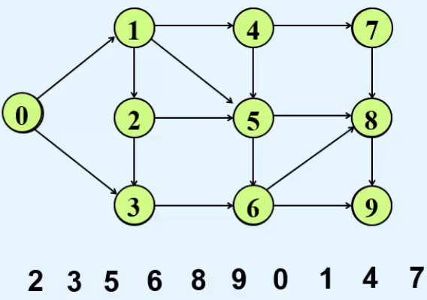  
=> **Vertices 0 1 4 7 are not reachable from the start vertex 2**.  
=> **Now we take any vertex from the remaining unvisited vertices and start the traversal again**.  
* Let’s take 0.  
* **So we have to keep performing BFS with different start vertices till all the vertices are visited if we want to visit all vertices**.

**Implementation of Breadth First Search**  
* **BFS can be implemented using a Queue**  
* We define 3 states for a vertex  
=> **Initial**  
=> **Waiting**  
=> **Visited**  
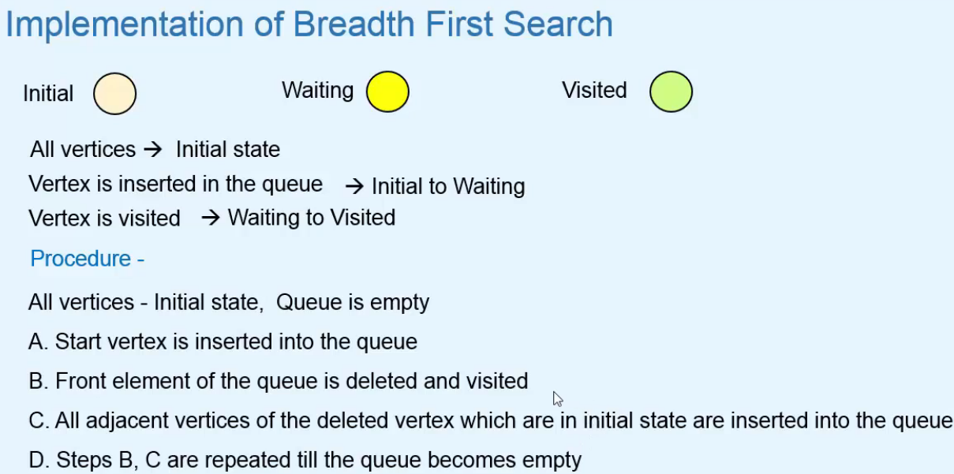  
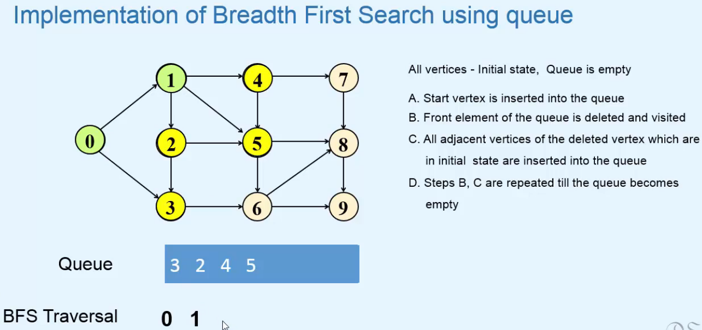  
=> 0 to queue -> changed to waiting  
=> 0 removed from queue -> changed to visited  
=> insert the vertices adjacent to 0 (not visited) to queue, so 1 and 3 to queue -> change to waiting  
=> 1 removed from queue -> changed to visited  
=> insert the vertices adjacent to 1 (not visited) to queue, so 2, 4, 5 to queue -> change to waiting  
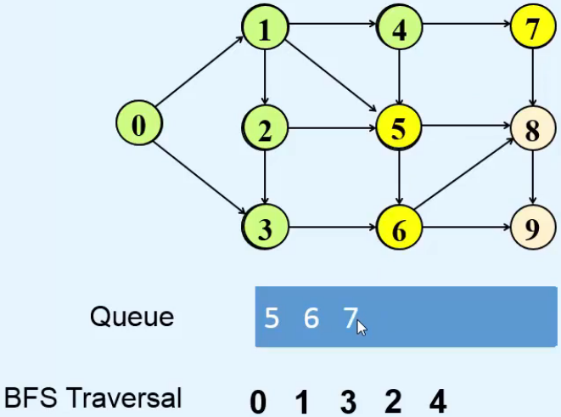  
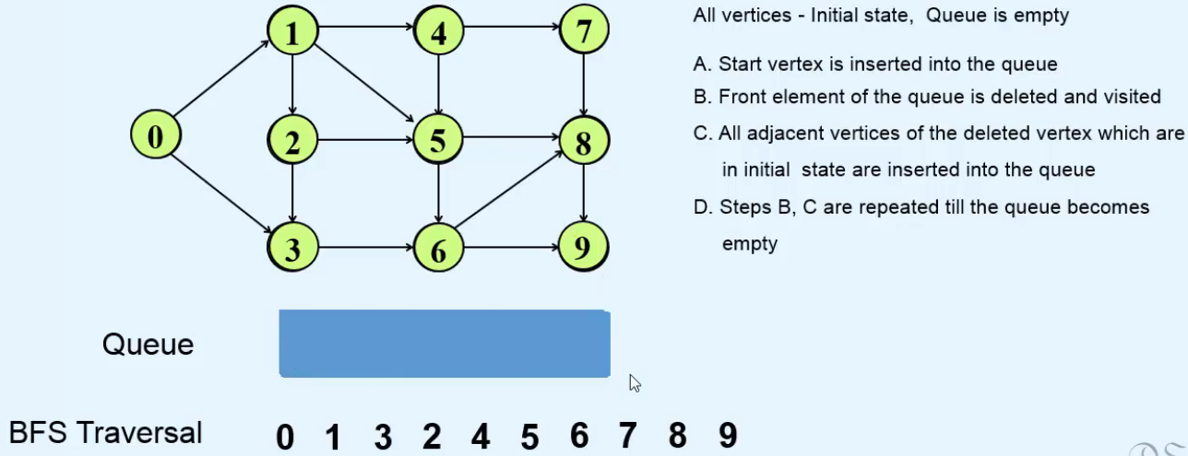

* **Code**:  
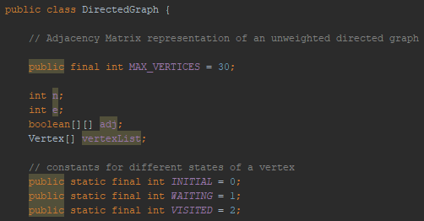 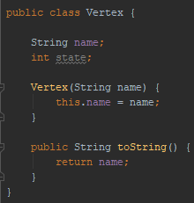  
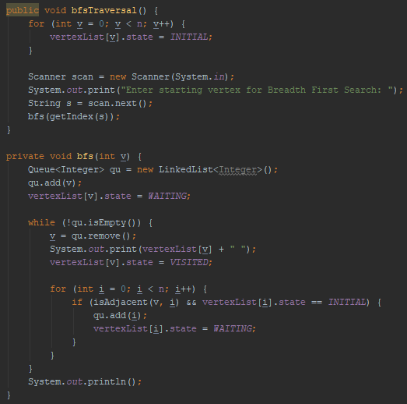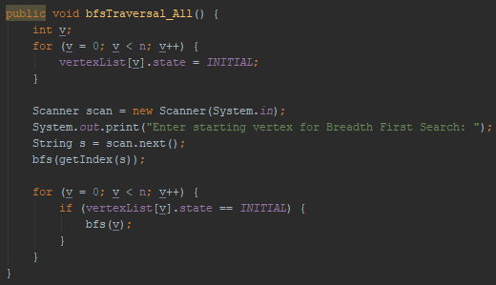

**Finding Shortest path in an unweighted graph**  
* To find the shortest path from start vertex to all of the vertices of the graph, we’ll make some additions in the BST procedure.  
* We’ll have 2 values associated with each vertex.  
=> **Distance value of v => shortest distance from start vertex to vertex v**  
=> **Predecessor value of v => vertex that precedes v in the shortest path from start vertex to v**

* **The Distance value will give us the shortest distance from start vertex to v**.

* **The Predecessor value will help us in obtaining the shortest paths**.

* **Whenever we insert a vertex into the queue, we’ll change its predecessor value and the distance value will be equal to 1 more than the distance value of the predecessor**.  
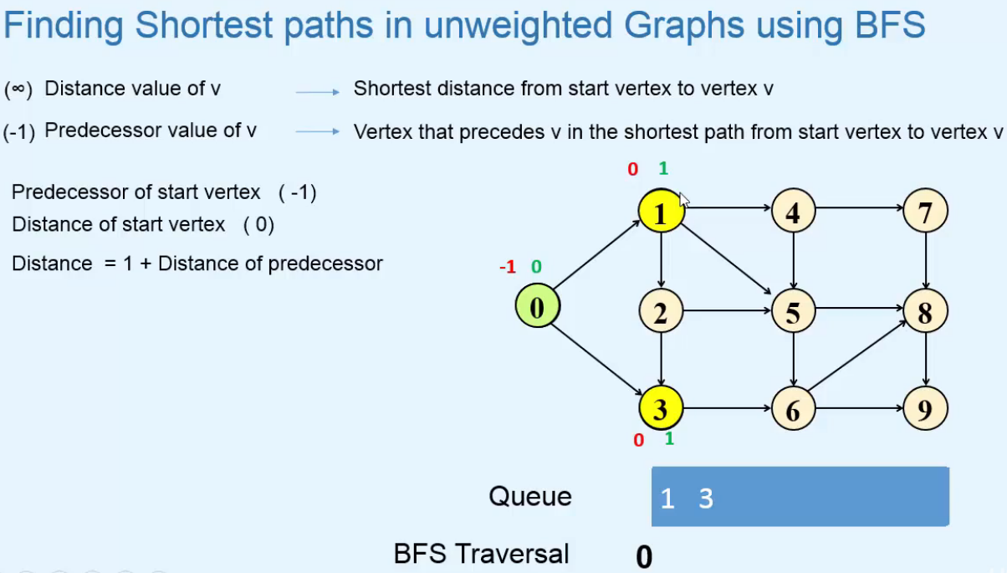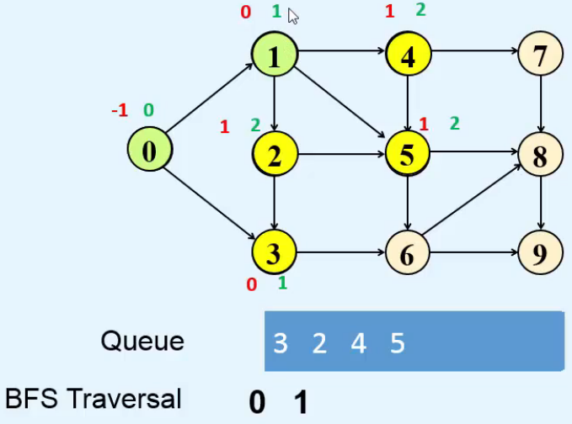 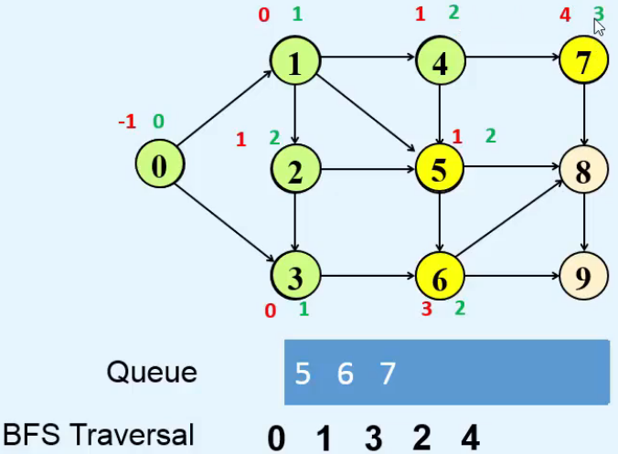  
  
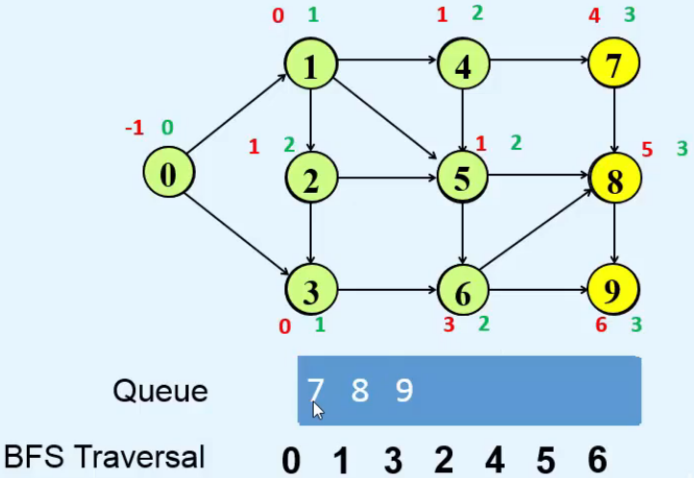

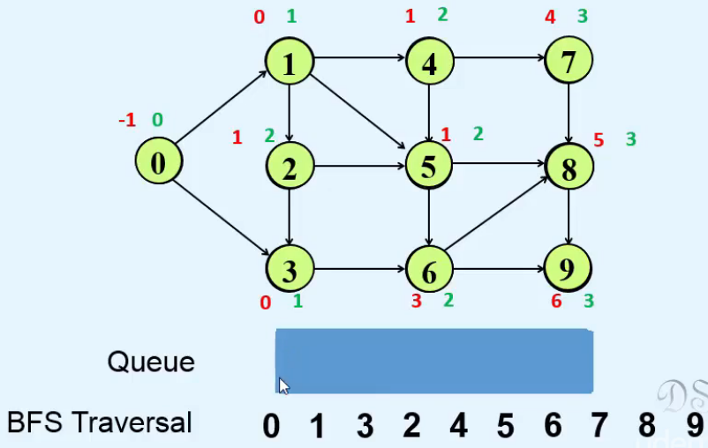

* Let’s say we want to know the shortest path from 0 to 8.  
* We use the 8’s predecessor to find it.  
=> **8 -> 5 -> 1 -> 0**  
=> So the path is: **0 -> 1 -> 5 -> 8**  
* **The shortest paths may not be unique, there can be other shortest paths but have same length**.  
* If a vertex is not reachable from the start vertex, then its distance value will remain oo.  
* **Code**:  
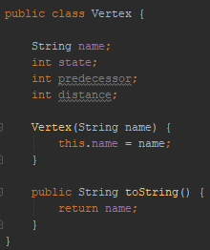 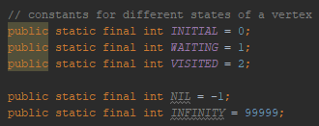

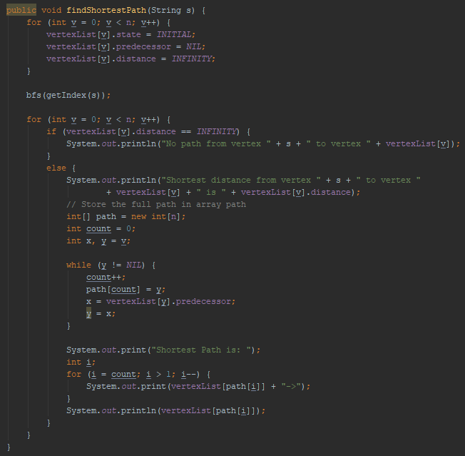  
* **We changed bfs() method**:  
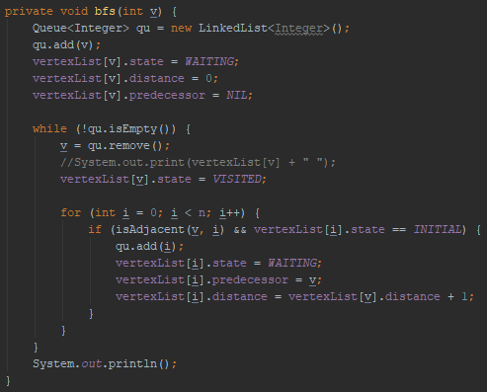

**BFS Spanning Tree**  
* **Breadth First Search Spanning Tree**  
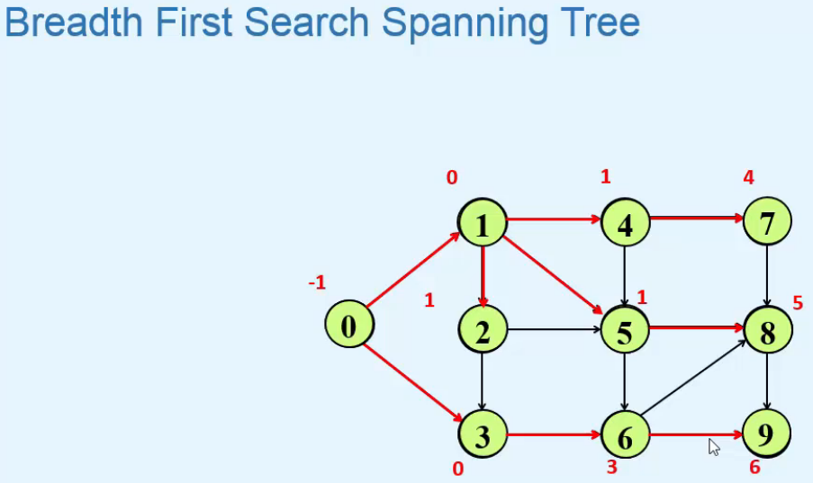  
* Here we show only the predecessor values.  
**Predecessor Subgraph** = **Spanning Tree**   
=> **We consider only those edges that join a vertex through its predecessor**.  
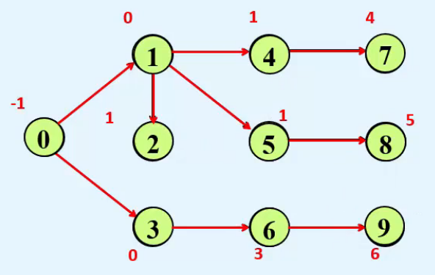  
**Root** of the Spanning Tree => **start vertex**  
**Tree Edges** => **all the edges**  
* **If all the vertices are not reachable from the start vertex**, then we’ll get a **BFS Spanning Forest**.  
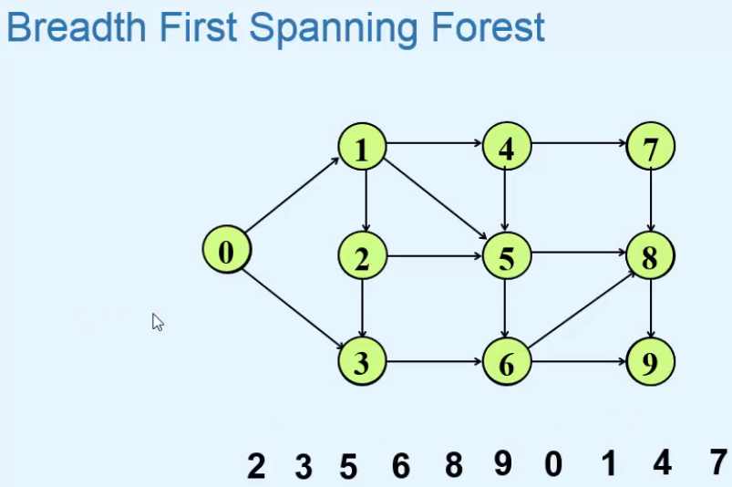 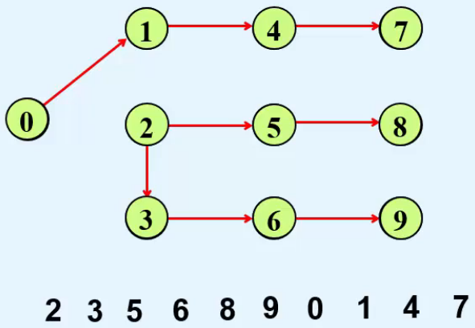  
=> Here we get 2 Spanning Trees.

* **Let’s see how to print the Tree Edges in our program**.  
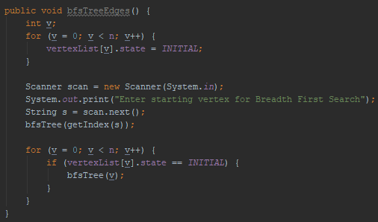  
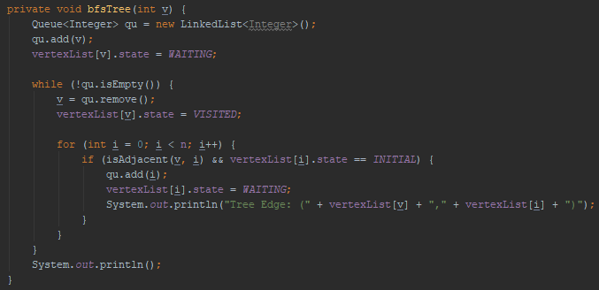  
=> **bfsTreeEdges() is the same as bfsTraversal_All () except it calls bfsTree()**.  
=> **bfsTree() is the same as bfs() except for the print line**.

**BFS in Undirected Graphs: Finding Connected Components**  
* BFS in Undirected Graphs is done in the same way as Directed Graphs.  
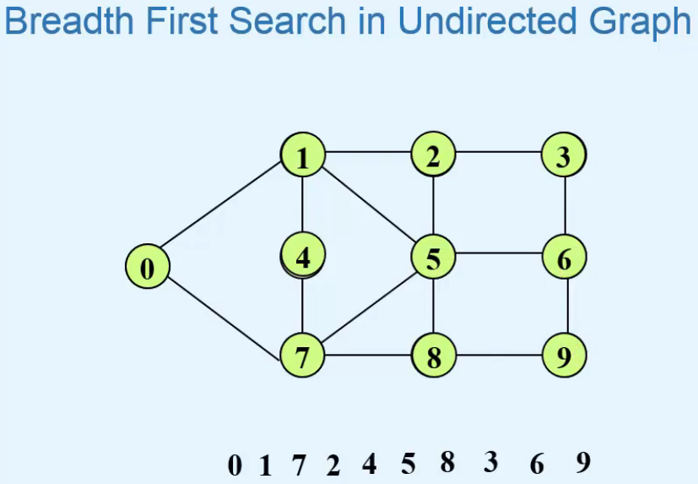  
bfsTraversal()  
bfs()  
bfsTraversal_All()  
=> **all 3 are the same as in a directed graph**.  
* **If the Undirected Graph is connected, then we can reach all the vertices by picking any vertex as the start vertex**.  
* **If the Undericted Graph is not connected, then we can reach only those vertices that are in the same connected component as the start vertex**.  
* **We can use BFS Breadth First Search to find out whether the Graph is Connected or not**.  
=> **If we can visit all the vertices of the graph by picking any arbitrary vertex as the start vertex, then the graph is connected**.  
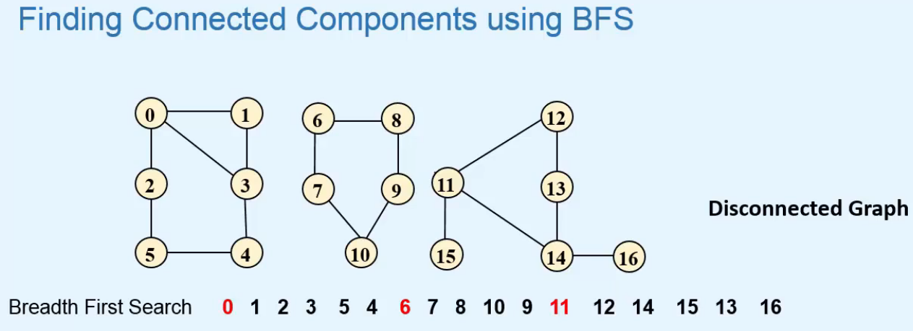  
* **BFS can also be used to find Connected Componenents of a graph**.  
=> **For this we’ll give a level to each vertex of the graph such that the vertices in the same component have the same level**.  
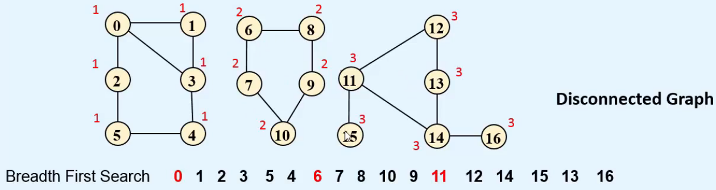  
* **Code**:  
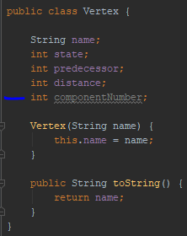  
=> If the componentNumber of 2 vertices is the same, it means they’re in the same Connected Component.

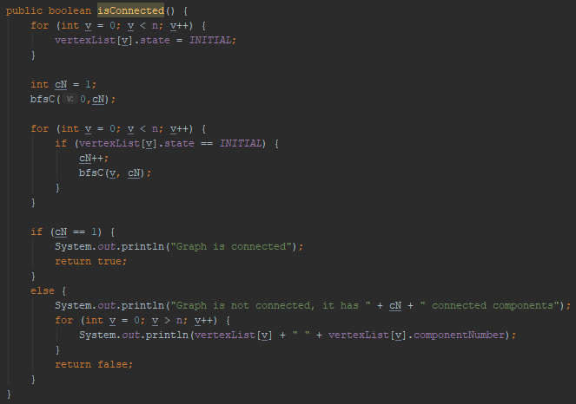  
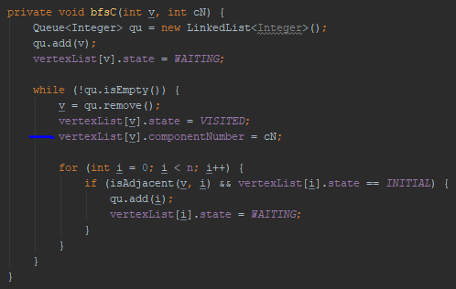

**Depth First Search**  
**Depth First Search Traversal**  
=> **We travel along a path in a graph and when a dead end is reached, we backtrack**.  
**Dead End** => **vertex with no unvisited adjacent vertices**  
=> **This process continues until we reach the start vertex**.  
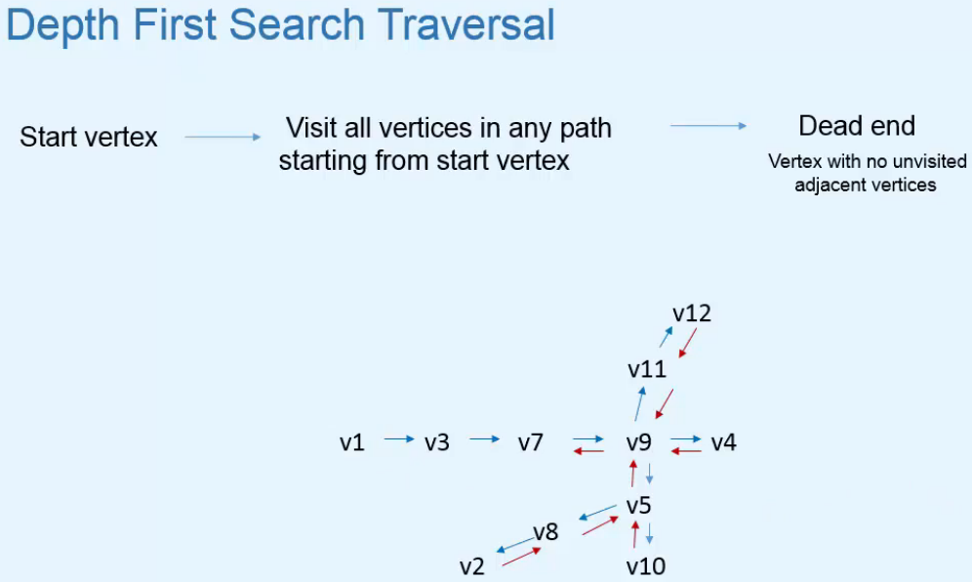  
* **The traversal is also not unique because the edges and vertices can be visited in different orders**.  
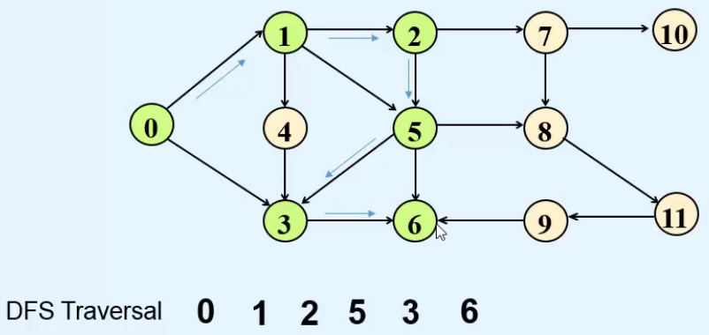  
=> **1st Dead End**.  
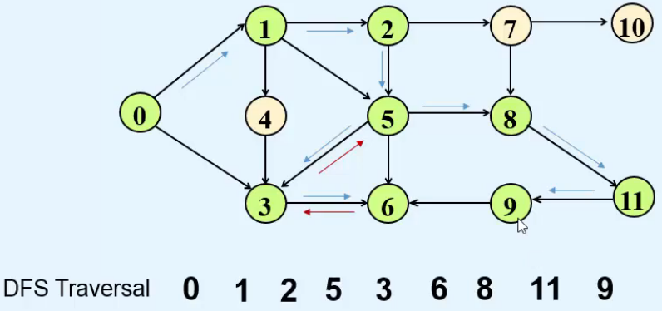  
=> **2nd Dead End**.  
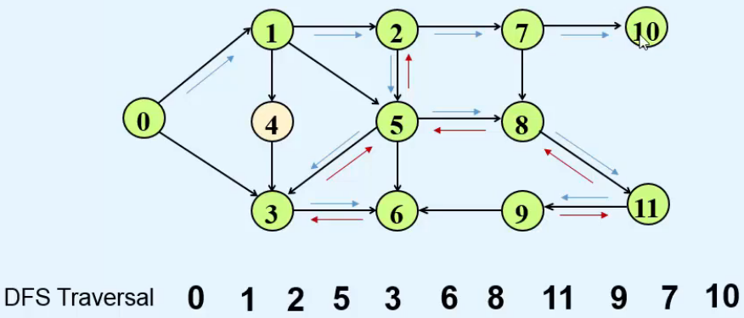  
=> **3rd Dead End**.

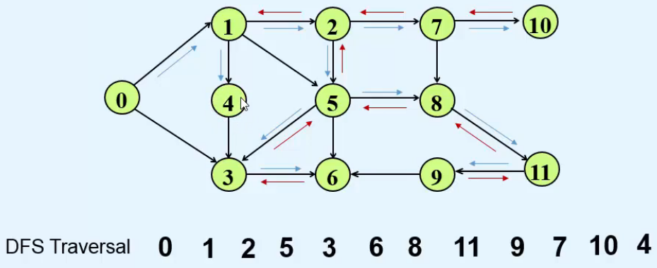  
=> **4th Dead End**.  
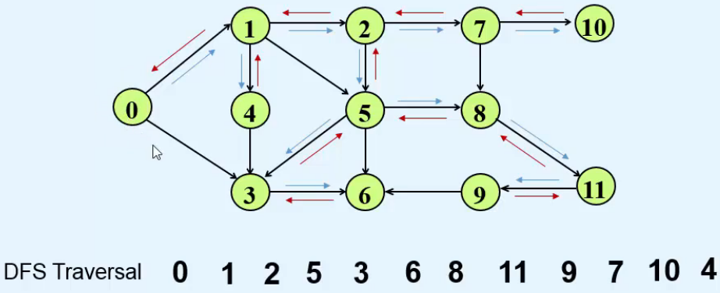  
=> **We reached the start vertex**.

**Implementation of Depth First Search through Stack**  
* Vertex => **Initial** / **Visited**  
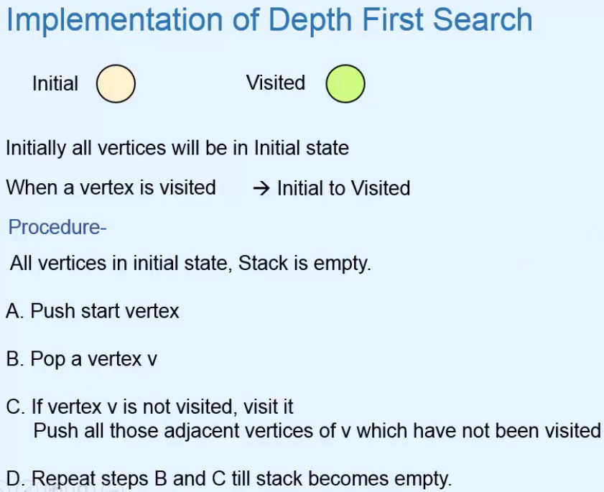

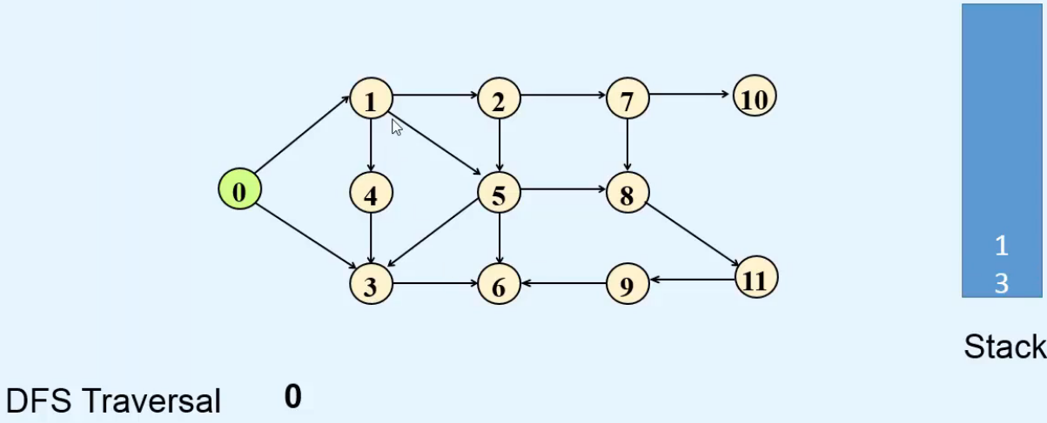  
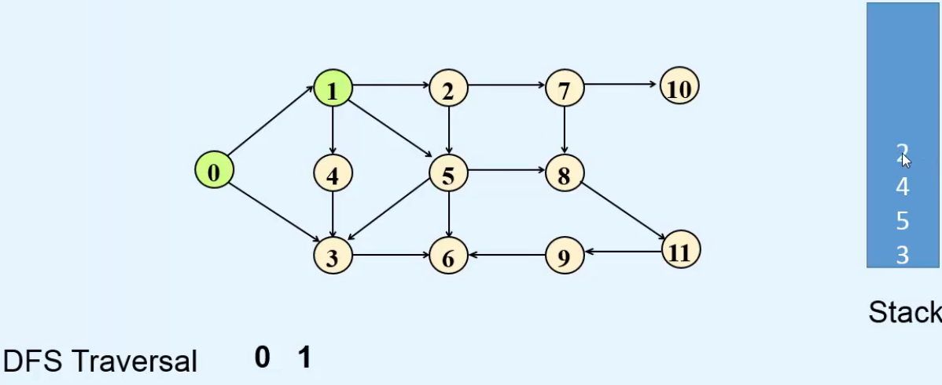  
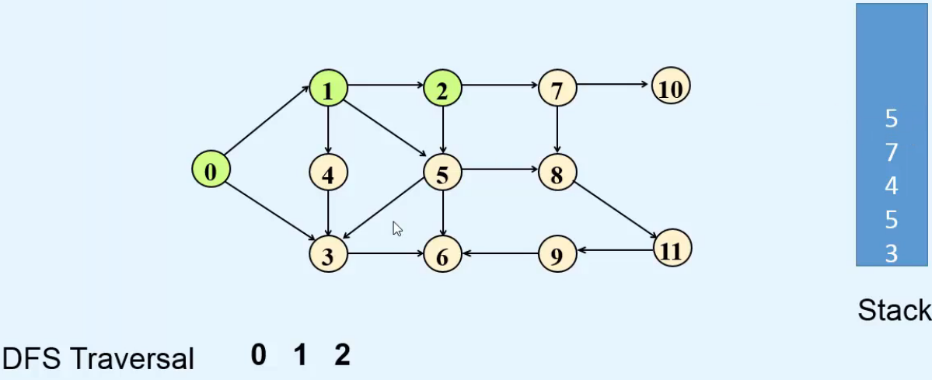  
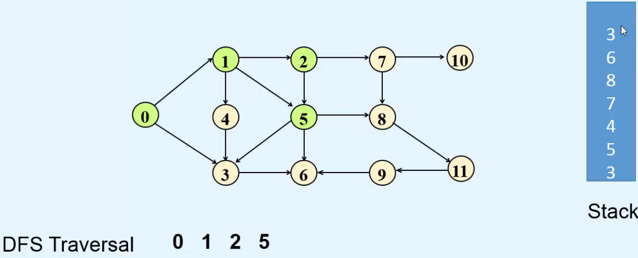

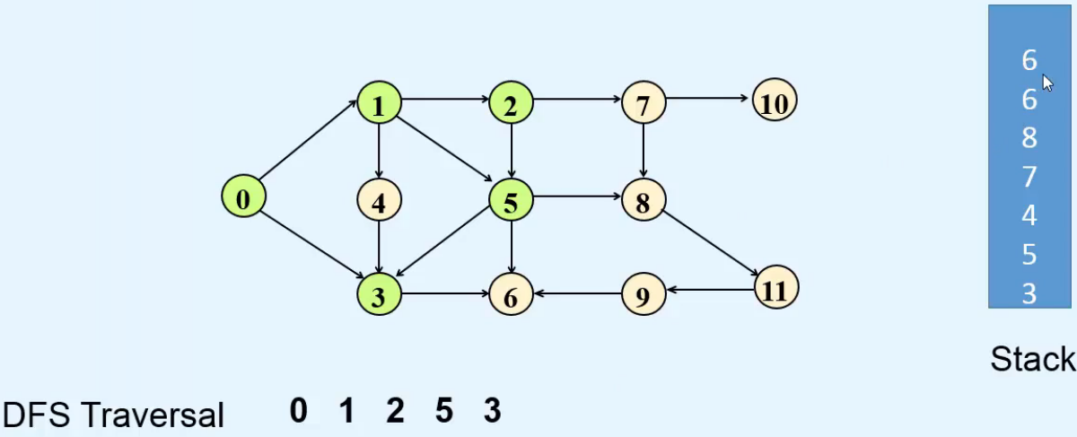  
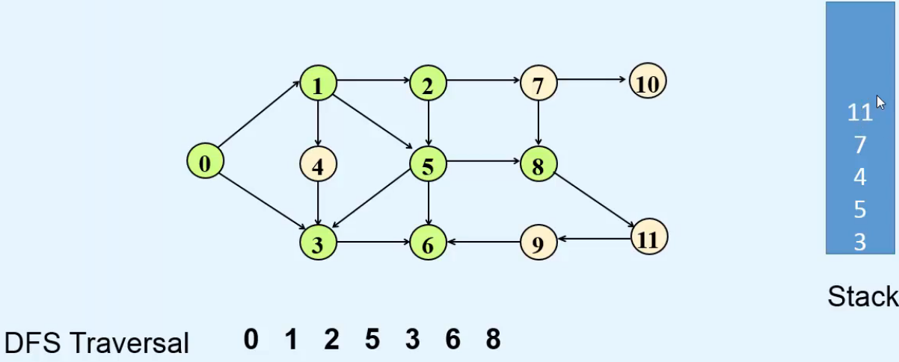  
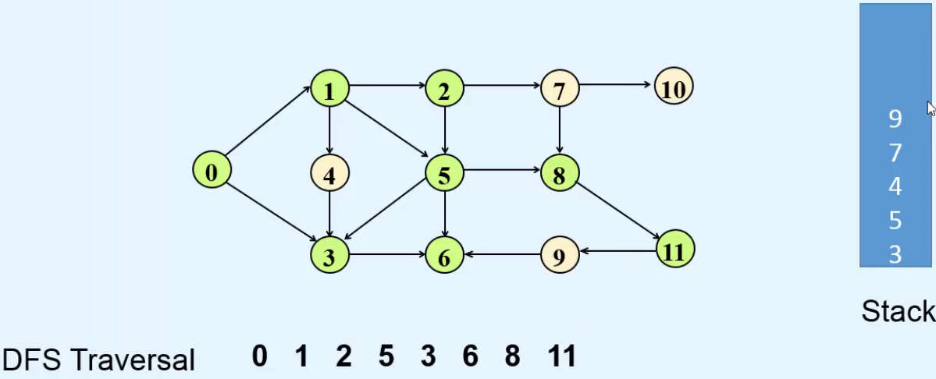  
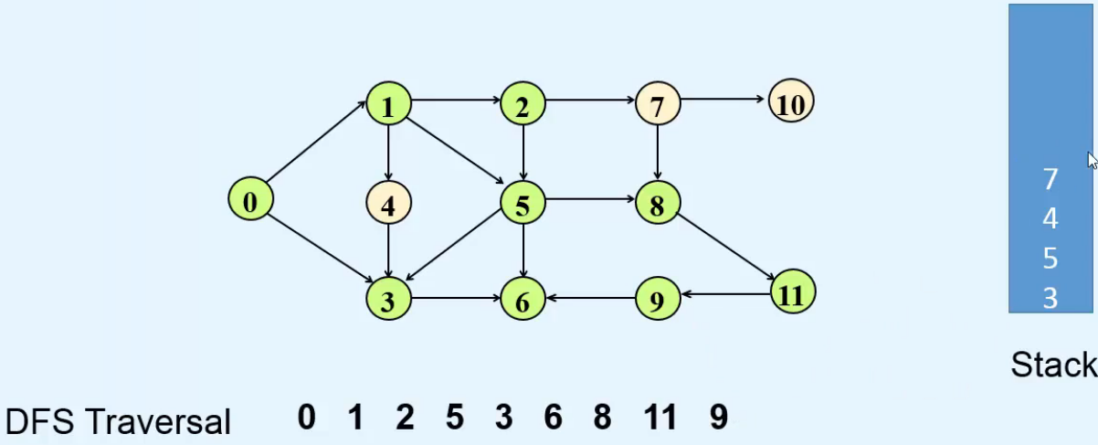

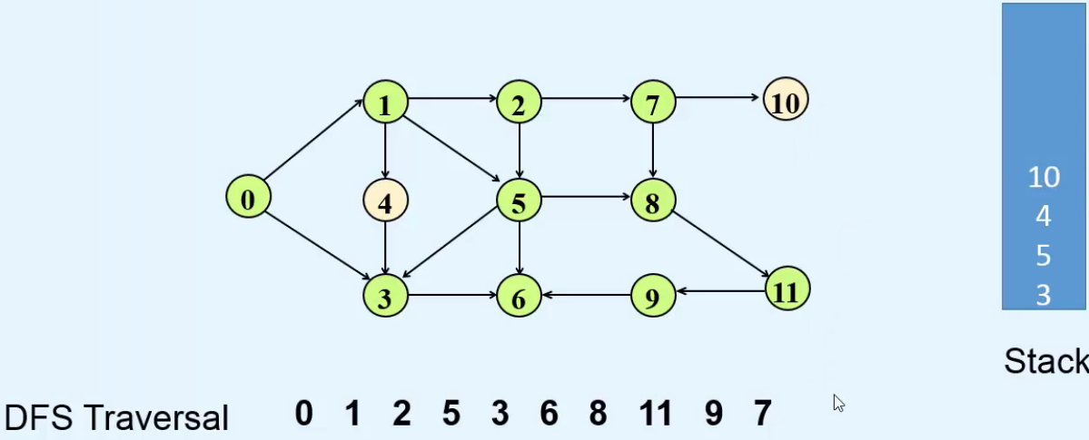  
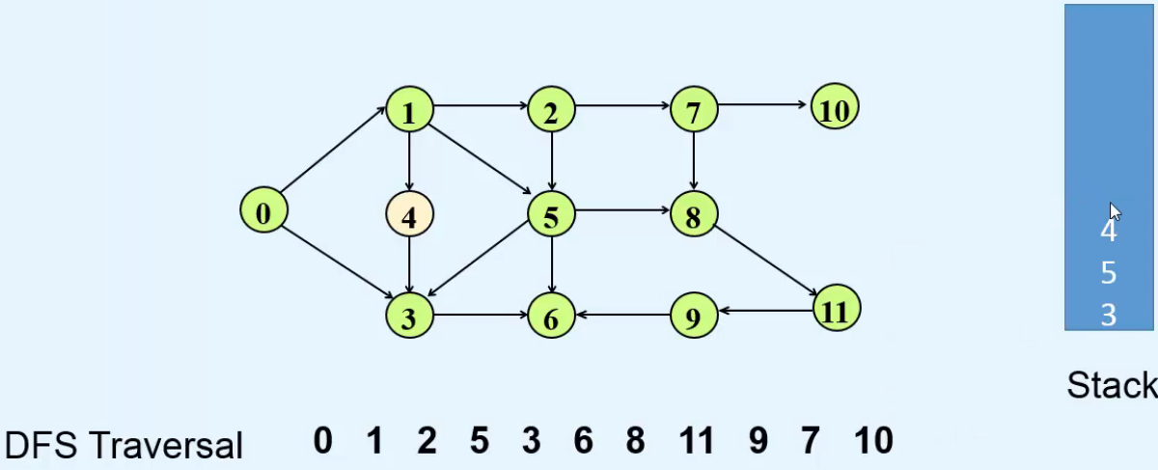  
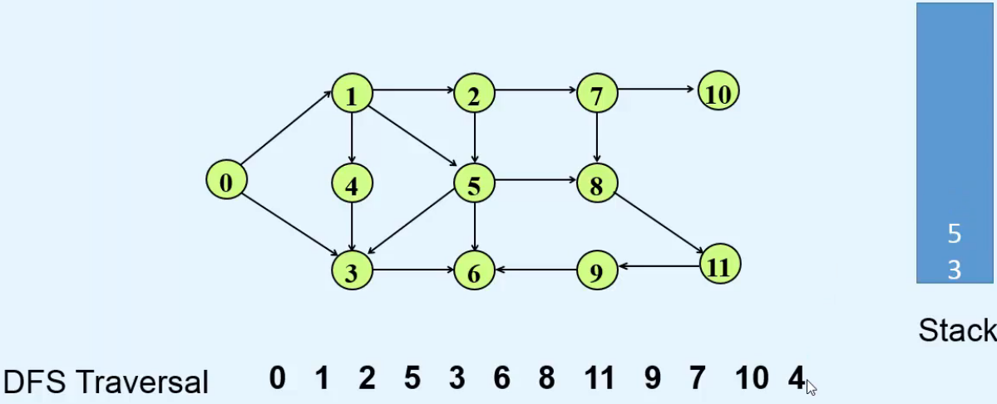  
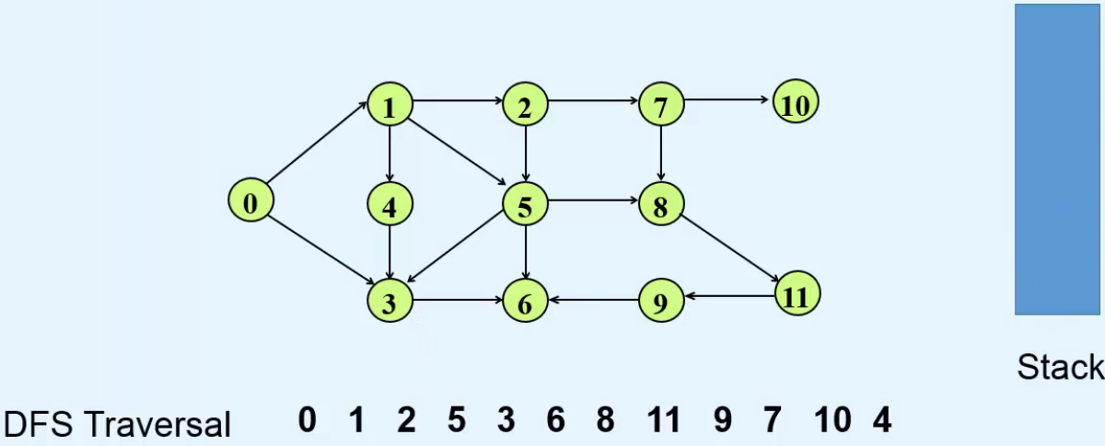  
=> **Stack is empty, Depth First Search is complete**.

* **Code**:  
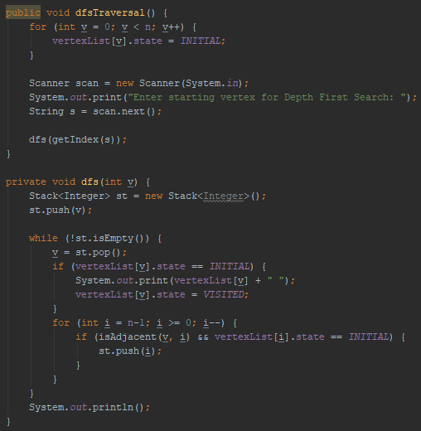  
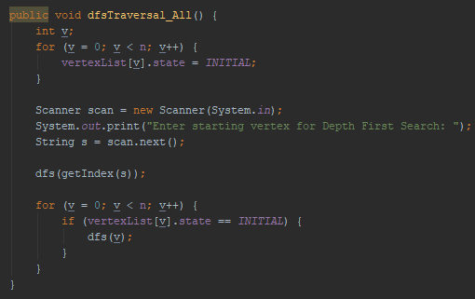  
**Depth First Search Spanning Tree**  
* **The predecessor is assigned when the vertex is pushed on the Stack**.  
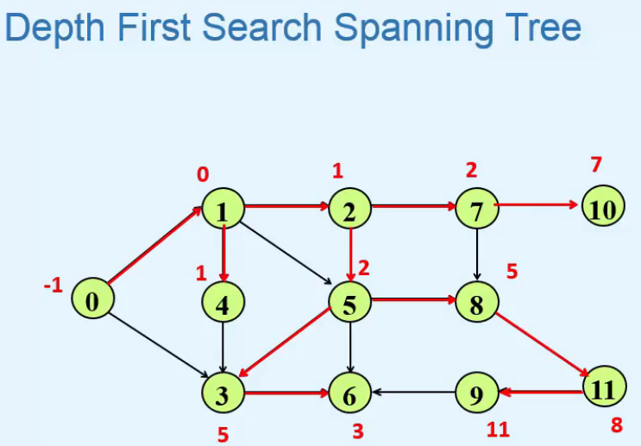 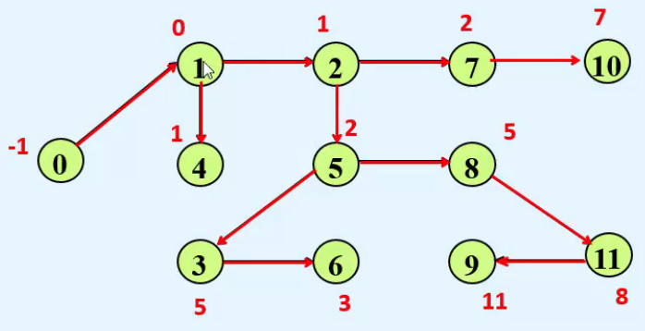  
=> **If we consider only those edges that join a vertex to its predecessor, then we get the DFS Spanning Tree**  
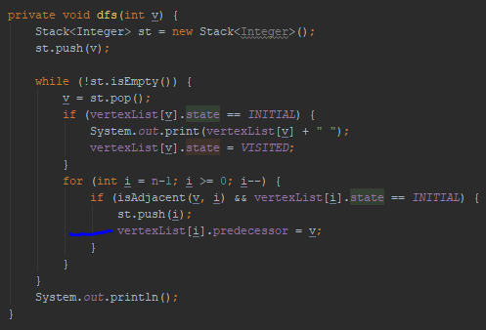  
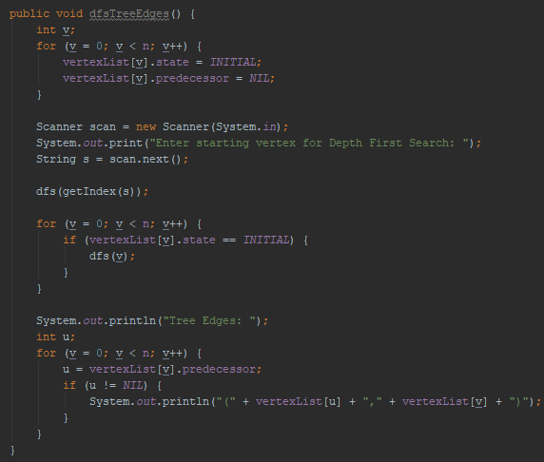* **Depth First Search in Undirected Graphs will procede in the same way**.  
* **We can use DFS to find whether the Graph is Connected and to find all the Connected Components in both Directed and Undirected Graphs**.

**Recursive Implementation of Depth First Search**  
* While recursively implementing DFS, we’ll define 3 states for a vertex:  
=> **Initial**  
=> **Visited**  
=> **Finished**  
* **Discovery Time**  
* **Finishing Time**  
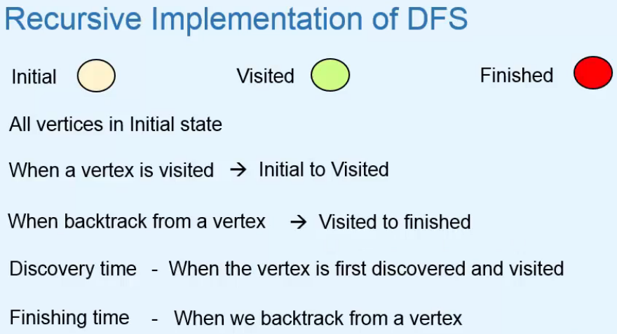  
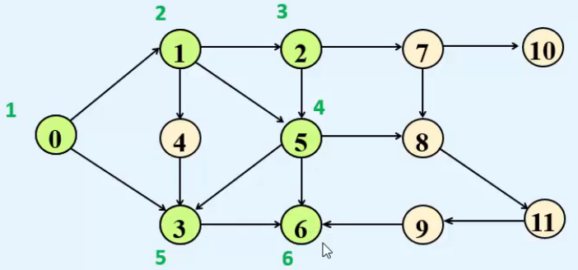 **=> Dead End => Backtrack.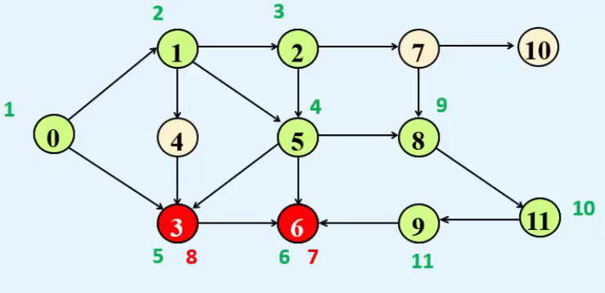 => Dead End => Backtrack.**  
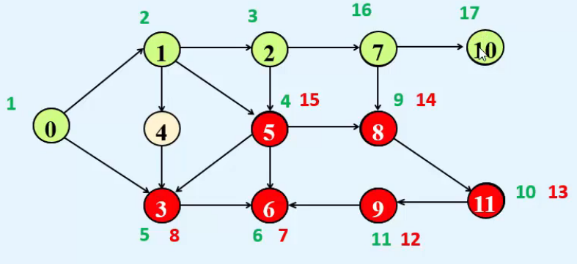 **=> Dead End => Backtrack.**

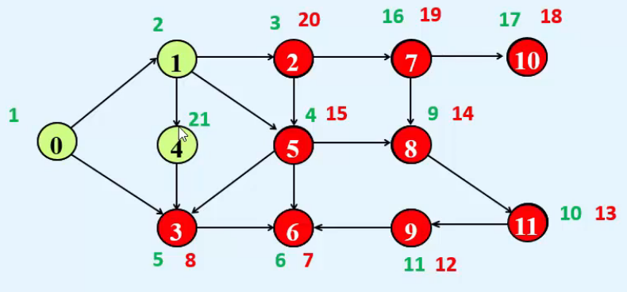  
**=> Dead End => Backtrack.**  
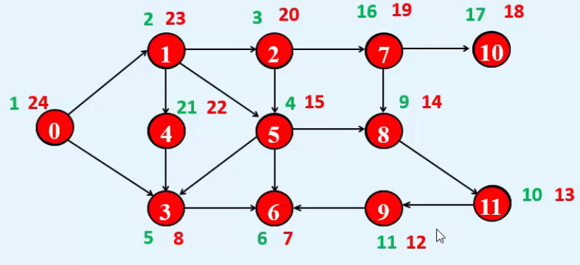  
**=> Dead End => Backtrack.**  
* **Code**:  
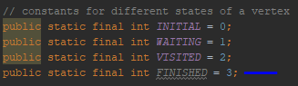  
* dfsTraversal() and dfsTraversal_All() are the same as in the Stack implementation.  
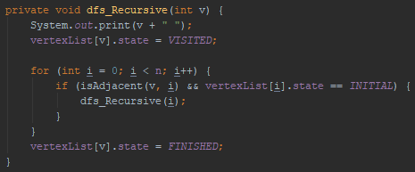  
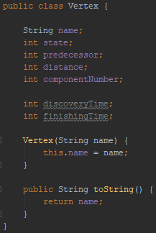 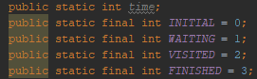

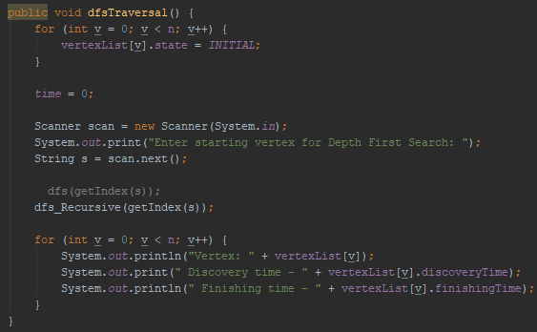 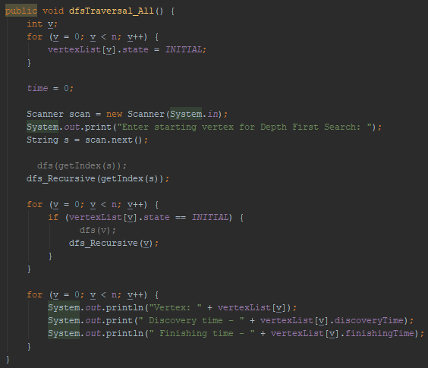  
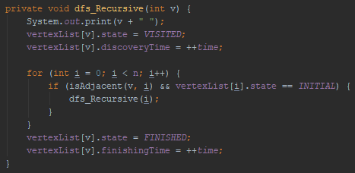

**Classification of Edges in DFS of Directed Graph**  
* Using DFS, we can classify the edges of a directed graph into 4 types:  
**Tree Edge** => **Edge included in the DFS Spanning Forest**  
**Back Edge** => **Edge from a vertex to its Spanning Tree ancestor**  
**Forward Edge** => **Edge from a vertex to a Spanning Tree non-son descendant**  
**Cross Edge** => **All remaining edges - if there is no ancestor/descendant relationship between the vertices, it can exist between 2 vertices of the same Spanning Tree or between 2 vertices of different Spanning Trees of the Spanning Forest**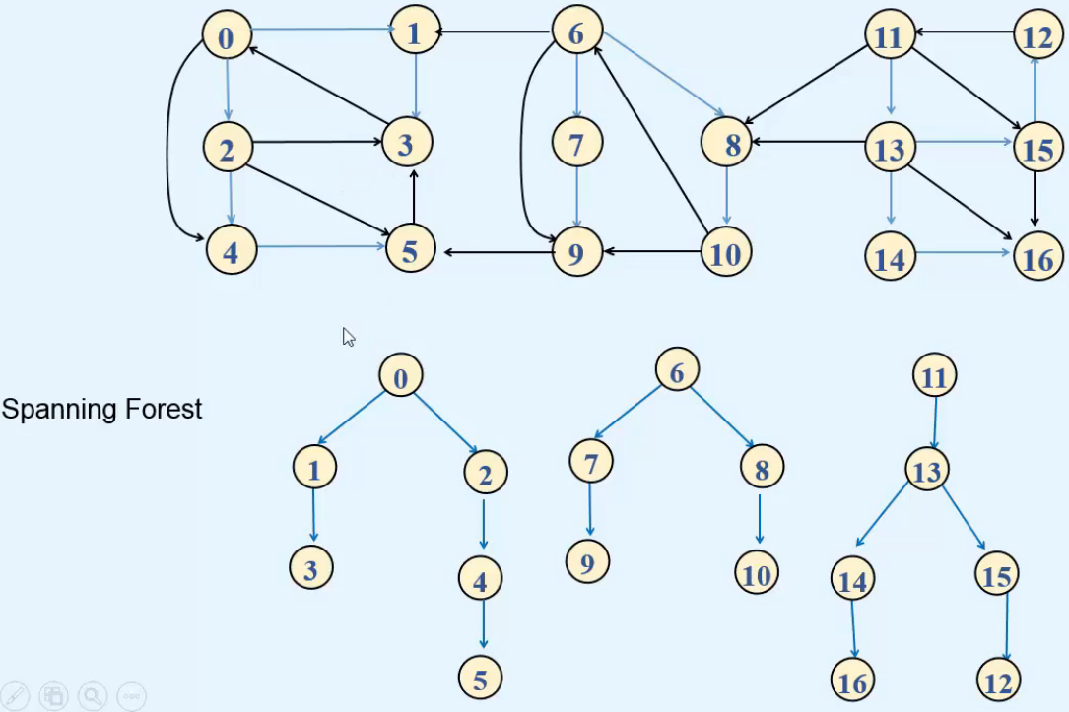  
=> **Tree Edge = Blue**  
=> **Back Edge = Green**=> **Back Edge = Red**=> **Cross Edge = Orange**  
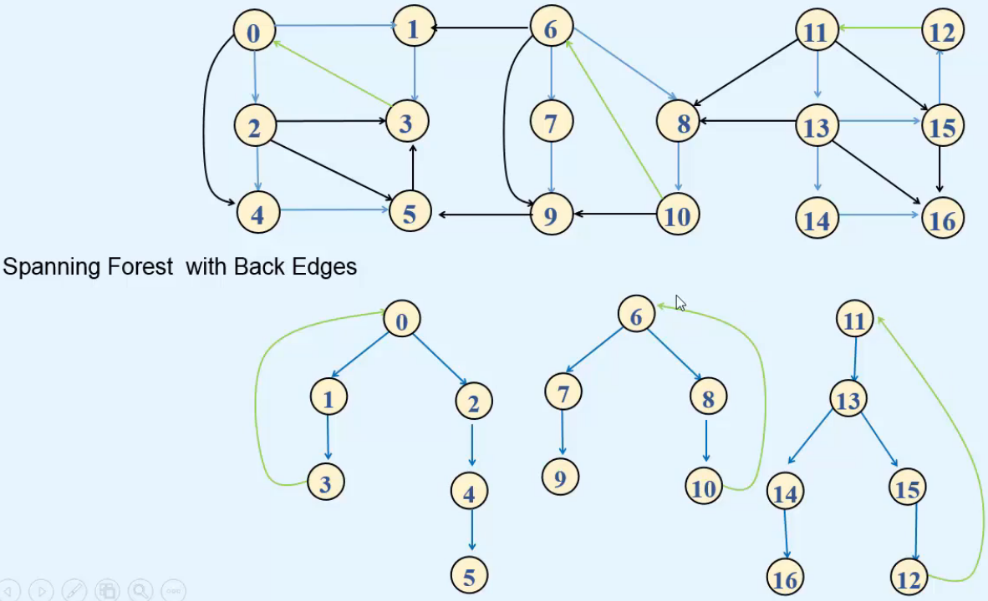

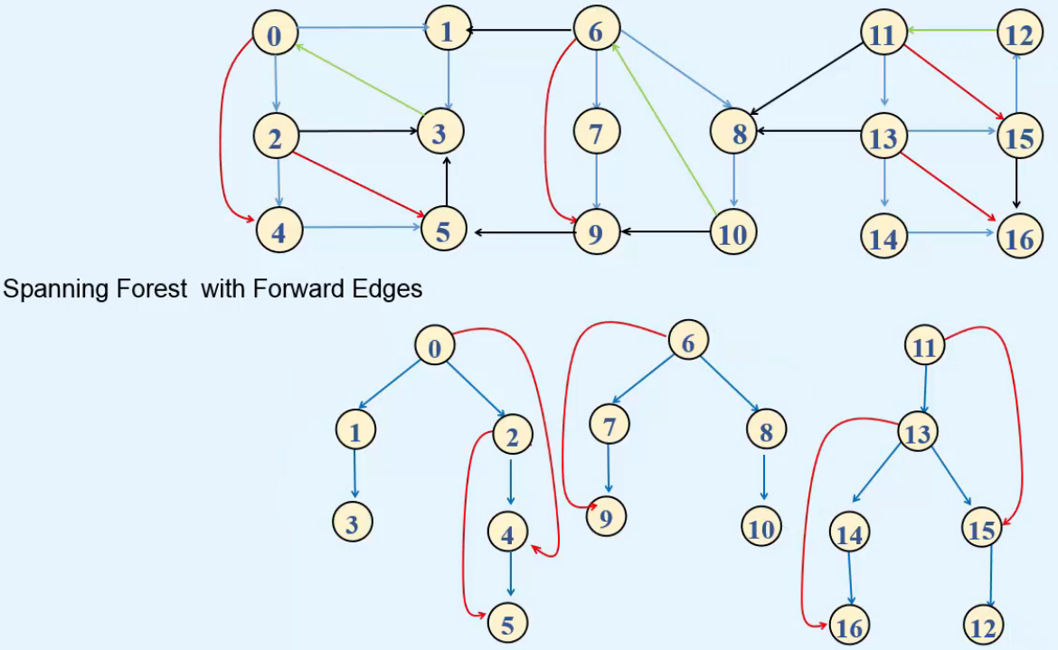

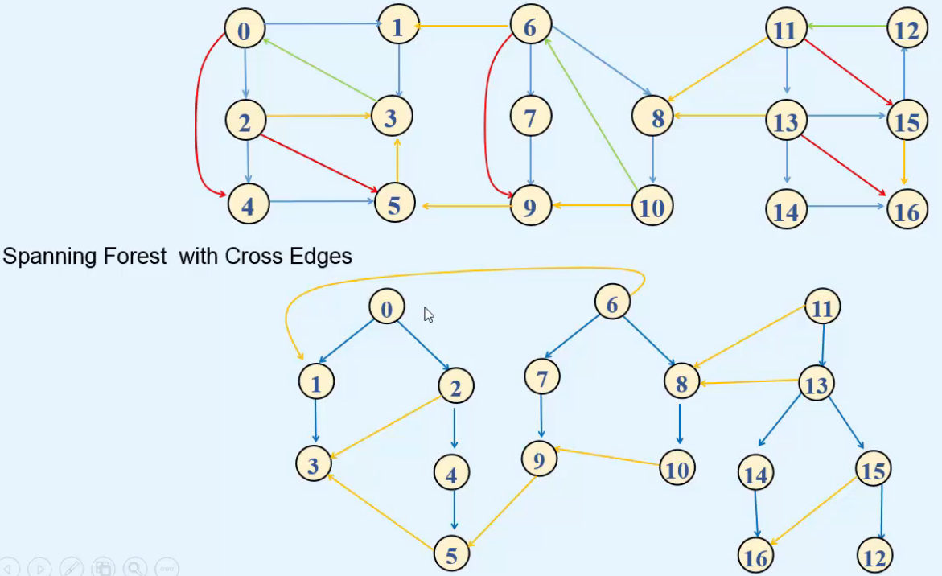  
=> We can see that the Cross Edges can exist between 2 vertices of the same Tree.  
=> Or between 2 vertices of different trees - 6 -> 1.  
=> There’s no ancestor/descendant relationship.

* **Code**:  
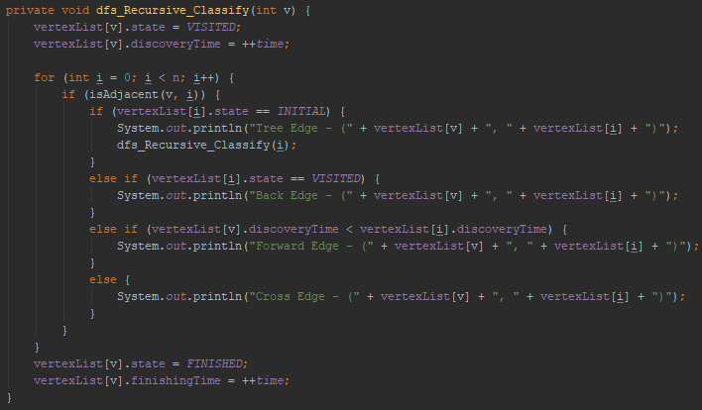  
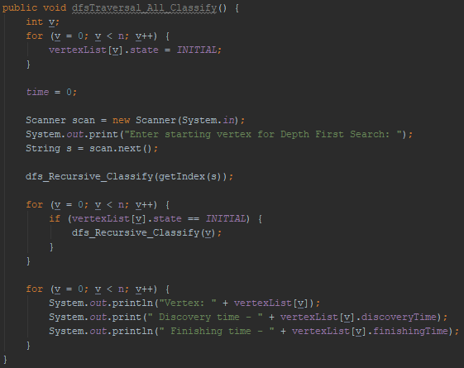  
* **If the graph contains a Back Edge, it’s Cyclic**.  
=> **So we can use DFS to find whether a Graph is Cyclic**.  
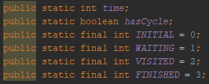

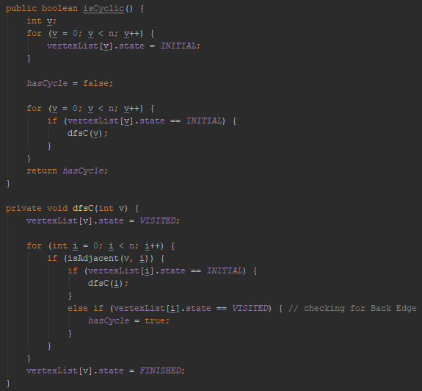

**Classification of Edges in DFS of Undirected Graph**  
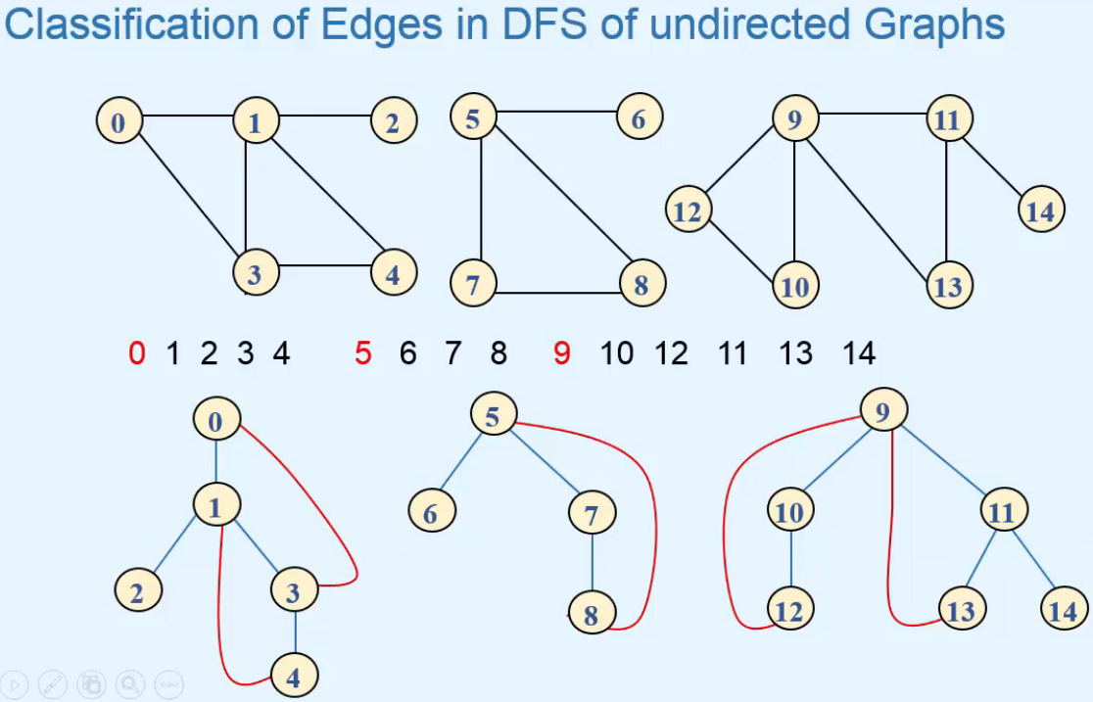  
=> **The bottom is DFS Spanning Forest**  
=> In Undirected Graphs we have only 2 types of Edges.  
1) **Tree Edges = blue**  
2) **Back Edges = red**

=> **There’s no difference between Forward and Back Edges**.

=> **Cross Edges are not possible - for example if there was an edge fro 2 -> 4, then we can think that it could be a Cross Edge but if there was an edge from 2 -> 4, then 4 would be visited after 2 and so 4 would be son of vertex 2 and that would be a Tree Edge**.  
* dfsTraversal(), dfsTarversal_All() and dfs() are the same as in Directed graphs.  
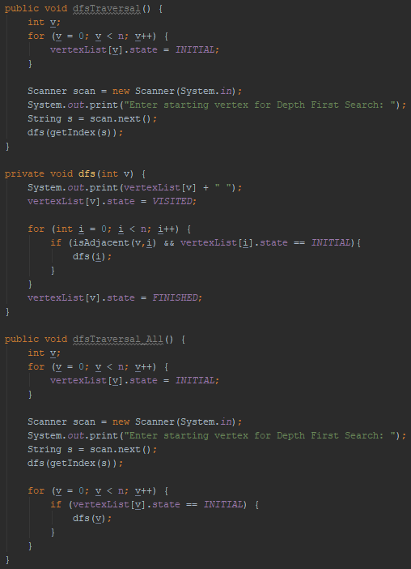  
=> **We need to record the predecessors** => because in an Undirected Graph and edge between 2 vertices u -> v is considered ??? BFS. Once from u with v as adjacent vertex and once from v with u as adjacent vertex.  
=> **This can create confusion in classifying edges so we classify an edge u -> v according to whether u,v is encountered first or v,u is encountered first during traversal**.  
=> example: Edge between 3 and 7 in Undirected Graph, if vertex 3 is visited first, then we’ll call edge 3-7 as Tree Edge and we’ll make 3 the predecessor of 7. When vertex 7 is visited, we’ll not consider the edge 7-3 because we know that this edge is already being considered since 3 is a predecessor of 7.  
=> **Here just like in the Directed Graph, if there is a Back Edge, it’s Cyclic**.

